 | 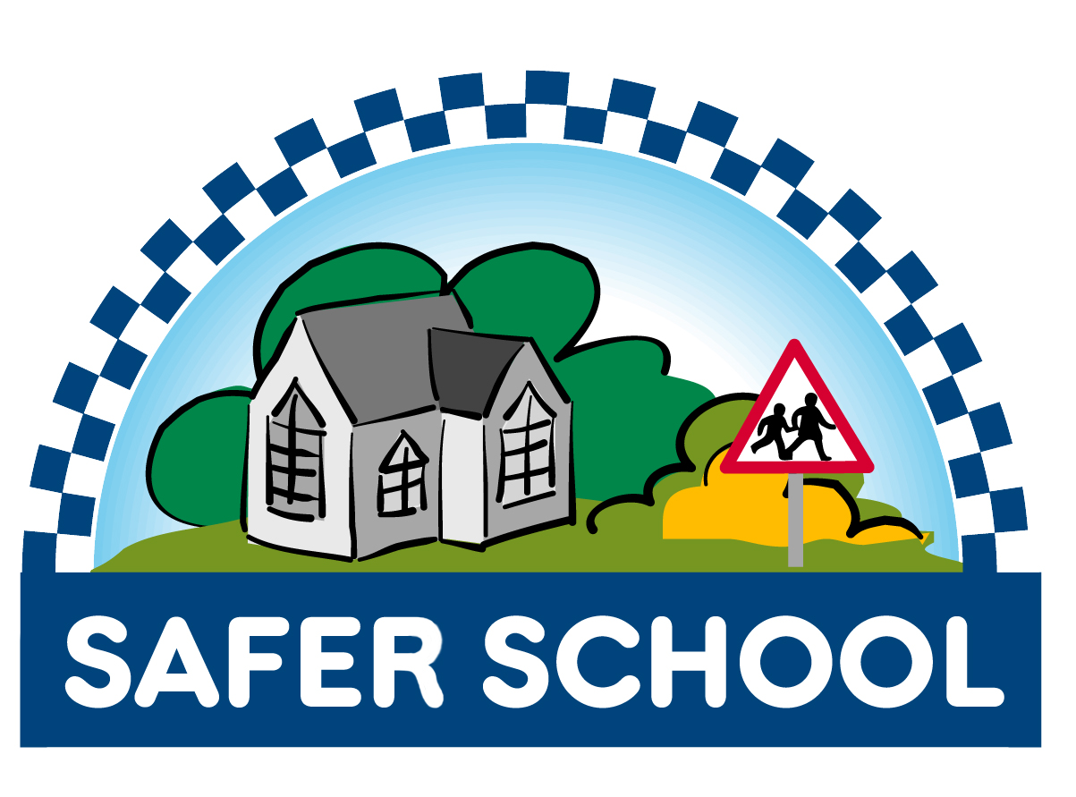

The Safer School Policy statement
Adopted by Oakmeadow CE Primary School

“The school has recognised the link between a successful school, pupil contentment, parent satisfaction, community involvement and the implementation of an effective risk management system.

Through the risk management system the school intends to establish the safety and security of staff, pupils and their property as a priority. This will be achieved by monitoring activity in and around school in a structured manner. Stakeholders in the school will be fully conversant with the system and will be actively encouraged to make constructive contributions.

The school will undertake to reduce levels of anti-social and/or criminal activity through the accurate recording of incidents with specific details and locations: this will allow preventative actions to be taken in conjunction with all stakeholders.

The school has committed to developing systems which will enable staff and pupils to concentrate on the process of education, secure in the knowledge that the environment in which they are working is as safe as possible”

The Safer School Group adopted this policy statement on 24.07.22 and will review in three years on 24.07.24

Mrs S Hill, Head Teacher/ Chair of Safer Schools Group

Mrs S Pugh, Chair of Governors
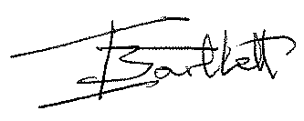 Shropshire Council Safer Schools

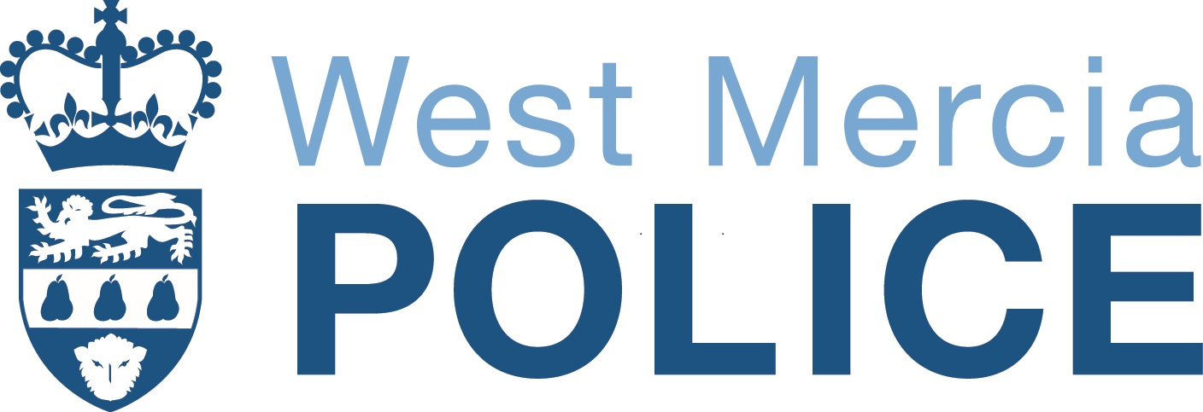 | 

